20140416 Home Phone Service for for 5$-$10 per Month with Battery Backup

9/20/2015 Abandon Ship, Project Cancelled

For those interested in a powerfailure protected project this is viable.

Cost $10/month for unlimited calls/text. (Republic Wireless).

Do not use the Moto X 1st gen. Mine seemed to have problems reconnecting to Wifi sometimes. The Moto G 1st gen however seems to have no problems reconnecting. I went back to MagicJack Plus (direct connect to router). $35/YEAR. Tranferred number from Republic quickly. No battery backup, but we have cell phones too.

# Notes:

*MagicJack Plus is a much cheaper option for those with Wifi and not desiring battery backup.*

*~$60 for ethernet(rj45) unit and $35/YEAR (not per month).*

*It appears are known problems with 2.4GB Wifi and Bluetooth 2.4GB so there may be problems with using bluetooth and 2.4GB Wifi. (use $10 cell plan, You can try the $5 plan).*

*Update: minimal problems using 2.4GB Wifi with Bluetooth.*

Tips:

Use 5 Ghz Wifi (on Moto X) to reduce compitition with 2.4 Ghz Bluetooth - This also may eliminate a problem that occurs when you reboot your router (Wifi sometimes does not connect to 5 Ghz Wifi if 2.4 Ghz is available from the same router. It will fail to connect to 2.4 Ghz Wifi and stop- Authenticates but fails to show “connected”).

*Current status of Grand Poo Bah’s Phone:*

1. *Using $5/mo plan with Republic Wireless (5 Ghz WiFi Moto X(used)).*
2. *Voicemail is on cell phone, not the cordless system (cannot turn cell phone off)*
3. *Moved bluetooth cell to room with bluetooth cordless base.*
4. *Home number successfully ported*

This project provides a solution for people who want cheap home phone service with some power outage options. You have the choice of using your personal cell phone (would connect to home phone system automatically when you are home) or provide a separate cell phone for home service. The use of a separate phone becomes viable when you look at the $10 a month plan available from Wireless. The $10 plan is 3G and provides unlimited voice and text (fine for our purposes).

Pros: Cheap Monthly Service ($10/mo.)

Battery Backup (keep ring volume up on the cell phone).

Cordless phone supports 2 cell phones via Bluetooth.

You can take your home phone with you on trips.

The cordless phone here (dect 6.0) has excellent range.

The cordless phone used here allows call blocking (2500 individual and area code).

The cordless phone used here announces the number calling (audible).

Cons: Have to buy a somewhat costly cell phone for the home (starting at $99 new -republic).

Requires a bluetooth cordless phone system. (starts at $40 new).

You may have poor audio if you use 2.4GB Wifi with this Bluetooth application.

(turn Wifi Off when using the cordless phone, keep cell phone near cordless base).

Caller ID does not include “caller name”.

Executive Summary:

You get a Republic Wireless Cell phone and connect it to your cordless phone base station via bluetooth. I am using the Panasonic Link2Cell cordless phones shown below. (Panasonic KX-TGE274S)

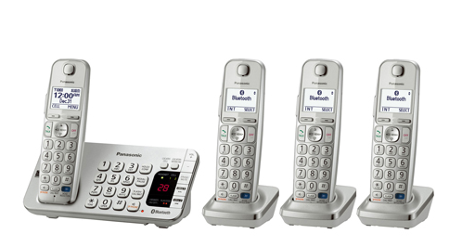

The Cheapest Republic Wireless Phone is the Moto E below: [Link to Republic Wireless Phones](https://republicwireless.com/info/phones/) I am getting a used Moto X for this particular applicaiton (just to have the other features for possible use with the kids).

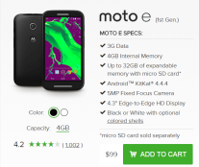

Select the Republic Wireless Plan (Cheapest we are aware of) $10

[Republic Wireless Plans](https://republicwireless.com/info/plans/)

How this works

<-Cell signal ---><--Bluetooth Signal-->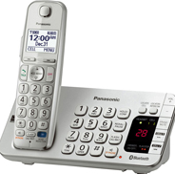<--Cordless->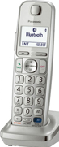

or

<-Wifi------------->

What is used in this project?

1. **Republic Wireless Plan** ($10.00 per month with battery backup (cell link). There is a $5 per month plan but that the wifi connection does not appear to have quality audio Moto E or G . We use Republic wireless as several club members use and like itintroduced by projectMonster. (The $10 plan uses 3G technology and WiFi, which we have deemed acceptable for our personal use).

Note: I have seen poor audio with an Iphone on another service.

1. **Panasonic Link2Cell Bluetooth Phone Answering** (starting at $39 for Panasonic KX-TG7872S Link2Cell Bluetooth Enabled Phone 7R on Ebay).

* Your phone should have at least Bluetooth 3.0 to include HSP (HeadSet Profile).
* The Moto E, G and X units support HSP.
* Cordless phone supports up to 2 Bluetooth phone connections (pick either phone from any handset).
* Supports up to 6 handsets
* Handset Equalizer
* Tons of other features described in a 96 page manual. [Manual](http://service.us.panasonic.com/opermanpdf/KXTGE260-MUL.pdf)

1. **Republic Wireless Phone**  (must be Republic Wireless Phone for the $10 plan) - Starts at $99.00 with Moto E) www.republicwireless.com

* Provides Battery Backup (with $10 plan)
* Moto X seems to support Wifi connection with sufficient quality using 5Ghz connection. (update will follow).

More Information:

To make a call.

Pick up the phone

Enter the number you want to call

Press the “Talk” button (similar to using a cell phone).

To receive a call

Pick up the phone

Press the “Talk” button. (there is an auto answer option).

For Pairing to No Land Line Phone

